Total Friction Forces of a Race Car

DISCUSSION:
We can define friction as the resistance to the movement of one body in relation to another body with which it is in contact. For example if we try to slide a wooden block across a table then friction acts in the opposite direction to the movement of the block. The amount of friction will depend upon the nature of the two surfaces in contact with each other. As it turns out, the rougher two surfaces are, the more friction there is between them when they rub together. By making things really smooth, or by adding lubricants like grease and oil, engineers work hard to reduce friction and in the long run, save energy.
Friction isn't always bad though. If you've ever tried to start running on a wet floor, you know that too little friction can just make you slip and slide. You need a certain amount of friction to get a grip in order to get yourself going. Have you ever noticed the tires that are on race cars? Racing tires are extra wide to give the race car more grip to stay on the track and not slide.

As we will discover in this unit of study, there are many forces of friction that act upon a car as it goes down the highway or around the race track. It is those forces that affect how fast the car can travel, how well the car will go around corners or if the car will slide out of control at any time. During the design stages of car production, engineers perform various tests to determine the effects of theses forces of friction and try to design cars to reduce these forces. Basically it is the total friction forces that slow you down. In order to overcome friction, you have to work harder. But remember, the energy doesn't just disappear, it's turned into heat!

When scientists measure friction, they use a term called the coefficient of friction and it is designated by the Greek symbol µ (mu). In this experiment, we will investigate what are the effects of the total forces of friction for a car and does it change significantly with speed? To determine the total forces of friction we will use the equation, V² = V_{o}² + 2aΔx to determine the acceleration of the car where V= velocity, a = acceleration, and x = the distance traveled. Newton’s law tells us that force is equal to the mass of the object multiplied by its acceleration which is also equal to the coefficient of friction multiplied by the mass of the object multiplied by the acceleration due to gravity or or 9.8 ^{m}/_{s}². (F = ma = μmg) In these two equations, the mass cancels out so we end up with μ = a/g.

Objective:
In today’s lab your job will be to find the coefficient of friction for a car and does it change significantly with speed?

Equipment:
- toy match box cars
- flexible race car track
- a meter stick
- a digital video camera

Experimental procedure:

- On a flat surface, lay out two to three meters of track
- Mark two 10 centimeter sections of the track with one meter space between the two sections.
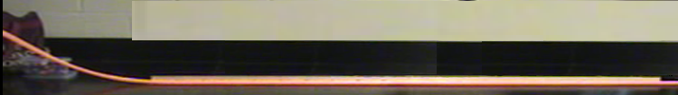
10 cm
10 cm
1 meter between each 10 cm section

- At one end, attach additional flexible track to serve as a launch ramp with variable height. (Stacks of books or ring stands work well)
- Set up the video camera to view the horizontal portion of the ramp and begin the camera as the car is released. You may need to do a few trial runs to get the video equipment set at a proper angle for the best results.
- Release the car from various heights to obtain different initial velocities. The height doesn’t really matter as long as your car travels the whole length of the track.
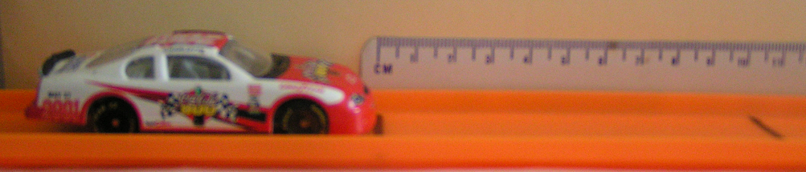

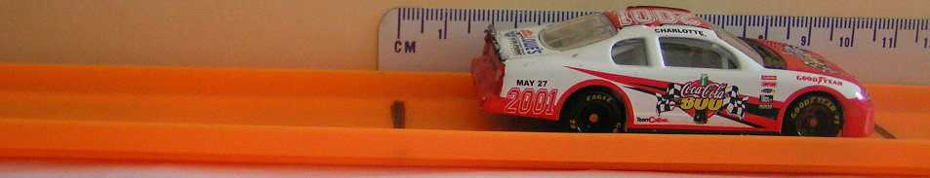

Data Analysis:
- Using a computer, analyze the video to determine the average speed of the car at the beginning of the horizontal motion and at the end of the horizontal motion. (S = d/t) d = to 10 cm, t = # of frames the car traveled divided by 30. Your teacher can help you with the computer analysis.

Example Data:

Ramp Height | # Video frames @ first 10 cm section | Time (sec)  (Frames/30) | # Video frames @ end 10 cm section | Time (sec)  (Frames/30)
30 cm | 7 | .23 | 14 | .47

To find the Velocity (S = d/t)
Ramp Height | Time (sec) | Distance (cm) | Initial velocity V_{o} (cm/s) | Time (sec) | Distance (cm) | Final velocity V (cm/s)
30 cm | .23 | 10 | 43.5 | .47 | 10 | 21.3

- Using the equation V² = V_{o}² + 2aΔx; solve for the acceleration of the car.
  - Since F = ma = μmg, the mass is not a factor and μ = a/g (g=9.8m/s²).
NOTE: In this calculation, values were converted to meters.
Ramp Height | Initial velocity (m/s) | Final velocity (m/s) | Deceleration  (m/s²) | Coefficient of friction forces
.30 m | .435 | .213 | 0.72 | 0.0734

Post Lab Questions:

1. What are the variables relevant to this experiment?

2. What are the sources of friction involved in this experiment?

3. Is the measured velocity an instantaneous velocity or an average velocity?

4. The camera takes pictures at a rate of 30 frames/second. Explain how the quality of the data would be affected, if at all, if the rate were 10 frames/second.

5. Explain what effect, if any, it would have on the data if the distance interval were 20 cm instead of 10 cm.

6. Explain what effect, if any, the mass of the car has on this experiment?

TEACHER NOTES:
This lab has been written as an introductory lab to forces and motion. It can be used to engage the students and lead to discussions of different types of forces, energy, and motions. You could develop vectors and force maps from this lab. This lab could also be used as an extension piece for the above concepts, depending on your classes.

Most labs which investigate friction are designed to verify the relationship that the force of friction is equal to the coefficient of friction (μ) times the mass (m), acceleration of gravity (g) and the angle relative to the horizontal (sinθ) giving the familiar equation F_{f} = μmg sinθ. This equation applies for sliding friction and it is often pointed out that the force of sliding friction is independent of the velocity of the mass.

Rolling friction is often neglected because the factors are much more complicated resulting in a relationship between rolling friction and velocity which is nonlinear. Although this lab exercise does not investigate all the factors affecting rolling friction it is designed for students to verify that the force of friction is related to the velocity of the object, and therefore, described differently from sliding friction.

In this lab the initial velocity and final velocity are measured over 10 cm intervals separated by a distance of 1.0 meters. Therefore, using the equation V_{f}² = V_{o}² -2aΔx, the acceleration (a) can be determined. Then using Newton's Second Law it is possible to calculate the force of friction acting on the car. This force is due to rolling friction and air resistance. If the car is launched from different heights, it is possible to take measurements of the friction acting on the car at different velocities and show the relationship between velocity and the friction acting on the car.

Since the initial velocity and final velocity are measured over an interval of 10 cm, the actual values calculated are average velocities. Because the intervals are short, it is a close approximation to say that the average velocities calculated are the instantaneous velocities at the center of the 10 cm intervals. If the distance intervals are made shorter, the calculated velocity becomes a closer approximation of the instantaneous velocity. If the distance intervals are made longer, at some point the relationship between velocity and friction will begin to skew the measured values and the average velocity calculated will no longer correspond to the instantaneous velocity at the center of the distance interval.

When studying sliding friction, it is discovered the acceleration caused by friction is independent of the mass. The same relationship is true for rolling friction. If students add mass to the car without significantly changing its aerodynamic shape, they should be able to verify this relationship.

Using Windows Media Player,
Click on Now Playing, on the drop down menu click on Enhancements, then click on Play Speed Settings. On this screen you can slow the video down to play one frame at a time. Each frame is 1/30th of a second. By counting the number of frames and dividing that by 30, this gives you the time the car traveled.

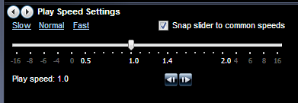

WEB Sites on friction:
http://www.newi.ac.uk/buckleyc/forces2.htm
http://www.reachoutmichigan.org/funexperiments/quick/dirtmeister/friction.html
http://www.school-for-champions.com/science/frictionrolling_tires.htm

